## Basics

* operating system
* free
* open source

### History

ken Thompson early 70s UNIX

MULTICS

UNICS

UINX

Linus Torvalds early 90s Linux

Richard Stallman Open source

Next → darwin

### standards

sys V

BSD

### Open source

1. sell the ice-cream, recipe secret
2. sell the ice cream, recipe public
3. free , recipe secret
4. free on sundays, recipe public

firefox

GIMP

Blender

Audacity

Wordpress

Linux

### Unix based systems

Solaris

AIX

Darwin

HP-UX

Xenix

FreeBSD

### Linux based

GNU

Red Hat Linux 1994

OpenSuse

Linux Mint

Fedora Core

Debian Linux

Elementary OS

Arch

Kali Linux

BOSS

Ubuntu

unix-like or linux

## shell

command line interpreter (CLI)

terminal

command prompt

sh

ksh

csh

tcsh

zsh

Fish

bash

### prompt

username@hostname folder

john khut ~

$ normal

>

# root

### command structure

ls

ls -l

command options arguments

command arguments options

### wild cards

*

?

[ ]

### environment variables

SHELL

PWD

PATH

LOGNAME

HOME

## Linux Architecture

### kernel

* core component

process management

creating, scheduling, termination

memory management

allocation, deallocation

device drivers

communication between operating system & hardware devices

system calls & support

interface for user applications to interact with the kernel

### system libraries

special functions

glibc

### system utilities

ls cp

ifconfig top

### user applications

web browsers

text editors

office suites

game

### shell

cli

### File system structure

inverted tree structure

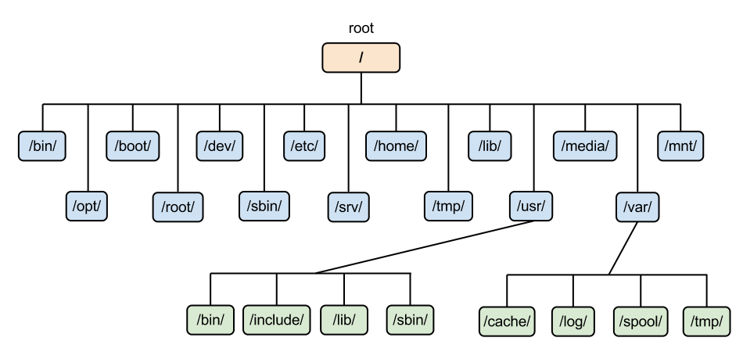

/bin essential command libraries

/etc configuration files

/home user home directory

/lib shared libraries & kernel modules

/usr user utilities & applications

/var variable data files (logs, databases etc.)

/dev device files (device drivers)

### /bootloader

loads the kernel into memory

GRUB

LILO

## basic commands

ls

-l long listing

-a all

pwd

print working directory

clear

clears the terminal screen

date

cal

bc

cd change directory

cd name

cd ..

parent

### getting help

#### whatis

#### man

b

f

search

/text

n next selection

shift+n previous selection

#### - - help

man pages

1 user commands

ls

2 system calls

3 library calls

printf

4 special files

/dev

5 file formats & conventions

6 games

7 miscellaneous

signals

8 system admin

## misc commands

### other

alias

unalias

hostname

uname

ulimit

history

shutdown

### find

-name

-type

d

f

-perm

### pipe |

## files & directories

### file

* unit of data storage

hello hello.txt

text files

.py

.c .cpp

.txt

binary files

#### view

cat

more

less

head

tail

nl

cp copy

-i interactive

-v verbose

mv move

rename

rm remove

-r (recursive for directories)

-f (force)

wc

-l lines

-c characters

-w words

touch

### directory

absolute

&

relative

/usr/bin

cd

.. parent

draintrain draintrain

- toggles

previous

~ home directory

. current directory

mkdir

rmdir (empty)

redirection

> filename

>>

### inode

ls -i

### links

hard links

symbolic links (soft, short)

## editors

GUI editors

CLI editors

vi (vim)

nano

gedit

sublimetext

vscode

emacs

notepad++

gvim

### vi (vim)

insertion mode

i

command mode

esc

:w save

:wq save & quit

:q! quit without saving

:w! save as

u undo

ctrl+r redo

dd cut

delete

p paste

yy copy

7yy copies 7 lines

cc copy

## users and groups

john

jane

root → superuser

### permissions

* modes

trainings_2024.data

jane → owner → user

| permission | | |
| --- | --- | --- |
| user | group | others |
| jane | training | others |
| read write execute | read write ~~execute~~ | read ~~write~~ ~~execute~~ |

avengers.txt

| user | group | others |
| --- | --- | --- |
| u | g | o |
| r w - | r w - | r - - |
| 1 1 0 | 1 1 0 | 1 0 0 |
| 6 | 6 | 4 |

6 6 4

o+w

666

chmod

chown

chgrp

useradd

passwd

groupadd

usermod

## grep

### options

-i

-n

-w

### patterns

(regular expressions)

^ matches the beginning of a line

[ ] matches any one of the enclosed characters

{ } specifies the number of occurrences of the preceding element

{3} occurs three times \{3\}

{1, 4} occurs one to four times

{2,} occurs more than once

$ matches end of a line

### extended

(egrep)

## file system types

Ext (extended file system)

journaling

ext4

XFS

FAT32 (exFAT)

VFS

(virtual file system)

procfs (process file system)

## boot

1. BIOS/UEFI initialization

* BIOS
* UEFI (unified extensible firmware interface)
* hardware initialization
* POST
* system’s firmware
* configure hardware components
* identify bootable devices

1. Bootloader Stage

GRUB

LILO

* stage 1: BIOS?UEFI loads the 1st stage of the bootloader from MBR
* stage 2: menu to the user (if configured)

load the linux kernel and initial RAM disk (initramfs/initrd) into memory

1. Kernel Initialization

loaded the kernel

hardware initialization

mount the root file system

loading initial RAM disk

1. INIT system
2. init system

/etc/init.d

1. systemd (modern)

/etc/systemd

5. User space initialization

* starting user services
* launch login prompts
* user login
  + desktop or shell is started

imp files

GRUB configuration

kernel image